**ALASKA LEGAL SERVICES CORPORATION**

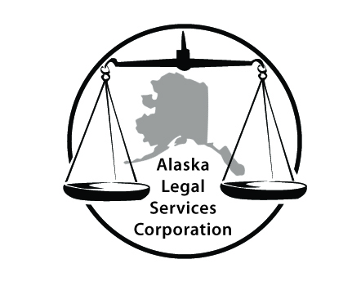

As a public service, volunteer attorneys and attorney-mediators organized by Alaska Legal Services Corporation are available for a brief, free consultation to help you finish your case today. The volunteers are private, independent lawyers and lawyer-mediators who do not work for the court and are not being paid by anyone.

The **Volunteer Lawyer** **CANNOT**

* become your lawyer for the case beyond today (unless you hire him/her separately)
* answer questions at any other time than today
* draft any documents
* keep copies

The **Volunteer Lawyer** **can provide:**

* Confidential advice
* Advice regarding possible responses to proposals made by the Court or the other party in your case
* Advice about the importance of seeking private legal counsel if warranted and affordable ways to do that
* Speak for you in court today or to opposing counsel only to help explain your desire or agreements based on the consultation

A **Volunteer Mediator CANNOT**

* provide legal advice
* answer questions at any other time than today
* draft any documents
* keep copies

The **Volunteer Mediator can provide:**

* Neutral legal information to both parties
* Facilitate conversation with both parties to fine-tune necessary details
* Keep information confidential from other party if you have asked for that

**You have the following responsibilities:**

You, as the party in the case, remain solely responsible for and in control of your own case at all times. You must remember that you alone are responsible for the case and meeting court deadlines and requirements that may be ordered today or at any other time in the case.

***If you want this free help, please sign the attached acknowledgement.***

***\*\*\*\* **** **** **** **** **** **** **** **** **** **** **** **** \*\*\*\****

This public service is brought to you by the **Alaska Legal Services Corporation,** a non-profit dedicated to providing legal assistance to people who lack the financial ability to obtain private counsel, to increase the availability of legal services of all kinds for people unable to afford those services, to promote knowledge about the law among those people. We appreciate everyone’s support. Please, *Pick. Click. Give.* when you sign-up for your PFD!

